Application Form
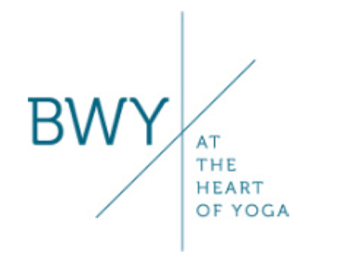 | BWYQ Progression Course in Yoga  Mar – Sept 2022  Application Form | 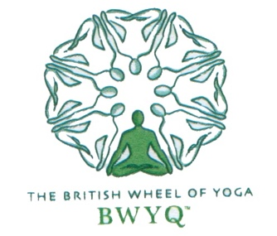

Strictly confidential.
Please insert a photo of yourself here. This is for identification purposes only.

BWY Progression Course Application | Today’s date:
Family Name
First Name/s
Date of Birth:

Address
(including borough)

Phone
Mobile
Email address
Years of yoga study
Experience in:
Asana
Pranayama
Meditation
Mantra
Yoga philosophy

Style of yoga you teach and Name of Certificate course tutor, if applicable
Why do you wish to take this course? (150 words max)

What are your other interests?
Academic background and relevant previous qualifications

Occupation
Are you currently teaching yoga?
Do you have other teaching experience?
Please detail any circumstances which you feel may affect your participation in the course.
I hereby declare that the above stated information is true, and I take full responsibility for any health conditions that may be affected by attending this course. I have read and agree with the Terms and Conditions as laid out in the prospectus.
Your signature Date:

Please return this form with an electronic copy of your BWY Certificate or other qualification to: info@cathymae.com.

